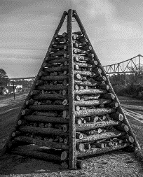
34th Annual Festival of the Bonfires
December 8 – 10, 2023 │ Lutcher Park │ 2545 Louisiana Ave. │ Lutcher, LA

2023 Santa’s Very Merry Forest

REGISTRATION FORM
Organization:
Contact Person:
Mailing Address:
City, State, Zip:
Telephone #:
Fax:
E-Mail:

Please remove all ornaments before 6:00 pm on Sunday, December 10, 2023.

Please mail this registration form and your remittance ($30) by Friday, November 24, 2023 to:

Festival of the Bonfires
PO Box 247
Lutcher, LA 70071

Please make checks payable to Festival of the Bonfires.

For questions
Contact Jamie Vicknair at jvick623@gmail.com.

